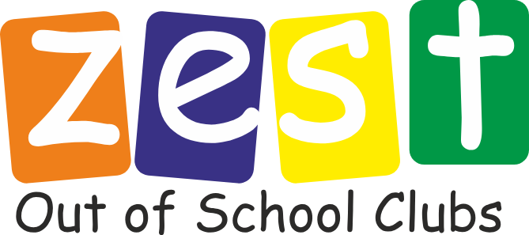

Dear Parents/ Carers,
Valley CiDS is delighted to offer a Zest breakfast club and after school club provision at Alfreton Christ the King Primary School.
Who are Valley CiDS?
Valley CiDS is a Christian charity based mainly throughout Derbyshire and Nottinghamshire. Founded in 2000 and committed to a vision of ‘Investing in the next generation’, Valley CiDS has become a well-established and respected charity supporting children, young people, and families through a growing family of projects and initiatives.
We are committed to embodying and expressing our core values of Hope, Belonging, Compassion and Inclusion, and believe that the successful delivery of our mission happens when people feel they belong and have a purpose, and where an inclusive community and family atmosphere is fostered.
About our Zest out-of-school clubs
As a charity we have been delivering our Zest out -of-school clubs for over 20 years, providing quality wraparound care through breakfast and after school clubs. Our aim is to enrich your child’s learning and development through games, creative play, teamwork, and craft activities, within a safe, caring, nurturing and inclusive environment.
Our settings typically celebrate Christmas and Easter with the children attending and are open to working alongside the school and families to explore an understanding of other religious celebrations. We believe in the importance of learning about different faiths and cultures, and how this leads to an enriched understanding of each other as well as contributing to an inclusive atmosphere.
We also provide healthy, nutritious meal options. We follow a carefully constructed menu plan which is shared with families, and children staying past 4:15pm will receive a light, nourishing meal. Fruit / vegetable sticks and drinks are always available to all children who attend the club.
Ofsted
All Zest clubs are Ofsted registered, where childcare provision is rated by a standard of ‘met’ or ‘not met’. I am so pleased to share that our most recent inspection of one of our sites achieved ‘met’ with no recommendations for improvements.
Our Staff
Our clubs are managed by Level 3 childcare qualified staff, and supported by club assistants who have experience of working with children. All staff undertake extensive training so that you can be confident that your child/the child in your care is receiving the best quality provision. This includes Safeguarding, Health & Safety, First Aid, Food Hygiene, Prevent and Equality and Diversity. We also adhere to the government guidance on ‘After-school clubs, community activities and tuition: safeguarding guidance for providers’.
Zest Oversight & Supervision
All of our clubs are overseen by our Out of School Club Coordinator, with further oversight provided by the charity’s Head of Children and Families Outreach. Regular visits from these staff members take place at Zest settings, to ensure that standards are being met, and that staff are being supported.
Timings and Prices
Timings and Prices are as follows:
Breakfast Club
7.30-8.45am - Flexi £6.00, contract £5.50
8.00-8.45am - Flexi £5.50, contract £5.00
After School Club
3.15-4.00pm - £5.00 for both contracted and flexi
3.15 - 5.15pm - £9.00 for both contracted and flexi
We look forward to welcoming your child/ the child in your care to Zest!
Further Information
Please feel free to visit our website www.valleycids.co.uk to learn more about our charity. Please contact Lauren (our Zest Manager at Christ the King) on 07562 388271 or alfreton.zest@valleycids.co.uk to request booking forms. You can also speak with Collette (our Out of School Club Coordinator) with any other enquiries on 07544 592776 or zest@valleycids.co.uk
Kind regards,
Kate Hill (she/her)
Head of Children & Families Outreach
Please note that I do not work Thursdays.
T : 01773 687979
M: 07484 021612 E: kate.hill@valleycids.co.uk

