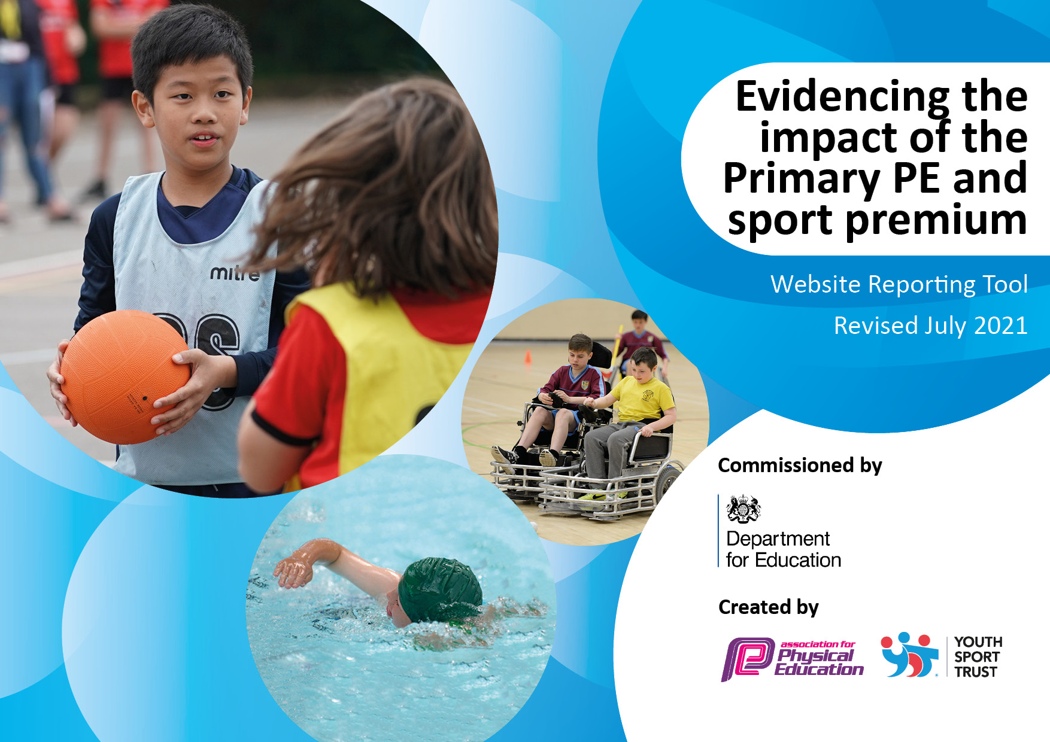
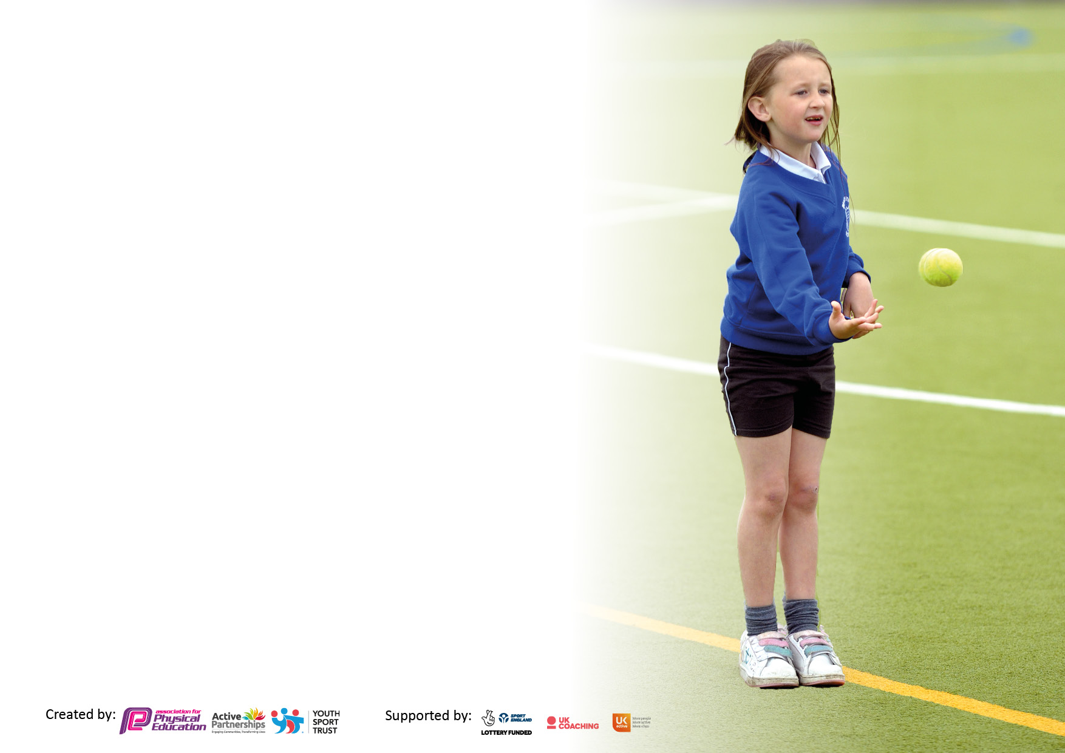

It is important that your grant is used effectively and based on school need. The Education Inspection Framework makes clear there will be a focus on ‘whether leaders and those responsible for governors all understand their respective roles and perform these in a way that enhances the effectiveness of the school’.

Under the Quality of Education Ofsted inspectors consider:
Intent - Curriculum design, coverage and appropriateness
Implementation - Curriculum delivery, Teaching (pedagogy) and Assessment
Impact - Attainment and progress

To assist schools with common transferable language this template has been developed to utilise the same three headings which should make your plans easily transferable between working documents.

Schools must use the funding to make additional and sustainable improvements to the quality of Physical Education, School Sport and Physical Activity (PESSPA) they offer. This means that you should use the Primary PE and sport premium to:

- Develop or add to the PESSPA activities that your school already offer
- Build capacity and capability within the school to ensure that improvements made now will benefit pupils joining the school in future years
- The Primary PE and sport premium should not be used to fund capital spend projects; the school’s budget should fund these.

Pleasevisitgov.ukfortherevisedDfEguidanceincludingthe5keyindicatorsacrosswhichschoolsshoulddemonstrate animprovement.Thisdocumentwillhelpyoutoreviewyourprovisionandtoreportyourspend.DfEencouragesschools to use this template as an effective way of meeting the reporting requirements of the Primary PE and sport premium.

We recommend you start by reflecting on the impact of current provision and reviewing the previous spend.

Schools are required to publish details of how they spend this funding, including any under-spend from 2019/2020, as well as on the impact it has on pupils’ PE and sport participation and attainment. All funding must be spent by 31st July 2022.

We recommend regularly updating the table and publishing it on your website throughout the year. This evidences your ongoing self-evaluation of how you are using the funding to secure maximum, sustainable impact. Final copy must be posted on your website by the end of the academic year and no later than the 31st July 2021. To see an example of how to complete the table please click HERE.
Created by:

Key achievements to date until July 2021 | Areas for further improvements
- Rising Stars – on Wednesdays Jack came into school to teach KS2 cricket.  - Year 4 were taught squash for a term from a former professional.  - Glen came into our school to provide children with a lunchtime club to get them more active after lockdown.  - Glen provided Year 3 & 4 with PE for a whole term focusing on Athletics.  - After lockdown all children were given the opportunity to attend Ozzy Obstacle and Tough Runner on our school field – organised by AVSSP.  - Hired balance bikes for all of EYFS children.  - Cycling proficiency for the Year 5 children.  - All years accessed Outdoor Learning with Adventure Unlocked.  - Whole active sports day for the whole school dedicated to healthy living.  - All children have accessed some swimming due to the pandemic for example, Year 5 attending. | - Carry out a PE audit with Olly to look at what we need to enhance the PE curriculum and support future spending.  - Dance workshop to provide children with a West End experience.  - Continue to support staff with creating a progressive curriculum using vocabulary and knowledge mats.  - Look at how we use assessment in PE and how this can be more effective and useful.  - Increased activity through trips E.G offering residentials to all year groups. This will give children the opportunity to take part in a variety of activities.

Details with regard to funding
Please complete the table below.

Total amount carried over from 2019/20
Total amount allocated for 2020/21
How much (if any) do you intend to carry over from this total fund into 2021/22 | £17830
Total amount allocated for 2021/22
Total amount of funding for 2021/22. To be spent and reported on by 31st July 2022.
Swimming Data
Please report on your Swimming Data below.

Meeting national curriculum requirements for swimming and water safety.

N.B. Complete this section to your best ability. For example you might have practised safe self-rescue techniques on dry land which you can then transfer to the pool when school swimming restarts.
Due to exceptional circumstances priority should be given to ensuring that pupils can perform safe self rescue even if they do not fully meet the first two requirements of the NC programme of study
What percentage of your current Year 6 cohort swim competently, confidently and proficiently over a distance of at least 25 metres?  N.B. Even though your pupils may swim in another year please report on their attainment on leaving primary school at the end of the summer term 2020.  Please see note above | 34% due to the impact of Covid-19
What percentage of your current Year 6 cohort use a range of strokes effectively [for example, front crawl, backstroke and breaststroke]?  Please see note above | 75% due to the impact of Covid-19
What percentage of your current Year 6 cohort perform safe self-rescue in different water-based situations? | N/A due to Covid-19
Schools can choose to use the Primary PE and sport premium to provide additional provision for swimming but this must be for activity over and above the national curriculum requirements. Have you used it in this way?

Action Plan and Budget Tracking
Capture your intended annual spend against the 5 key indicators. Clarify the success criteria and evidence of impact that you intend to measure to evaluate for pupils today and for the future.

Academic Year: 2021/2022 | Total fund allocated: | Date Updated:
Key indicator 1: The engagement of all pupils in regular physical activity – Chief Medical Officers guidelines recommend that primary school pupils undertake at least 30 minutes of physical activity a day in school |  |  |  | Percentage of total allocation:
 |  |  |  | %
Intent | Implementation |  | Impact
Your school focus should be clear what you want the pupils to know and be able to do and about  what they need to learn and to  consolidate through practice: | Make sure your actions to achieve are linked to your intentions: | Funding allocated: | Evidence of impact: what do pupils now know and what can they now do? What has changed?: | Sustainability and suggested next steps:
Inspire and motivate pupils to be active through attending termly whole class school AVSSP games events. | - Identify and book the school games events.  - Organise transport  - Celebrate participation via assembly  - Reward children with a personalised badge  - Develop celebration of members efforts in assembly using the SSP log poster and certificates  - Attend the AVSSP leadership conference with 16 pupils | Affiliation to AVSSP  Extra 12 places on the leadership conference £120 | - Develop sportsmanship  - Teamwork  - Increase children enjoyment in games and their fitness levels. | - Develop a cluster physical activity opportunity.
Engagement of all pupils in regular physical activity. | - Specialist PE coach in on Wednesdays for KS1 and then KS2 afterschool club.  - Arrange training with our PE specialist  - Use the AVSSP Fitness resource e.g. physical literacy and planning  - Lunch time club for KS2 on Wednesday | £5000 cost of our 1 day PE specialist  £250 Avssp fitness resource  AVSSP Affiliation Fee  £1000 | - Assess children with AVSSP format.  - Develop pupil voice to contribute to school sports and activities. | - Use this year’s school sports council members to support future members.  - Develop a lunch time leader to take on the training role, utilising the PE specialist to support this.  Attending the AVSSP Leadership conference Friday 8th November
The outdoor environment is used more frequently across the curriculum to promote learning and physical activity | - Adventure unlocked to promote outdoor learning in wider areas of the curriculum. Used right from Nursery to Year 6 | £5000 | - Motivate pupils to to more active  - Build on confidence  - Children are working together (good winners, good losers)  - Outdoor enhances children’s learning.  - Improve physical activity of pupils at break and lunchtimes.  - Pupils motivated and inspired to be active for more of the day  - Improved fitness with children more active in lessons  - Contributes to improved attainment (SATS results) | - Sports Coach to pass on game ideas to breakfast club regular staff for them to continue games on other days and into future years.  More children taking part in physical activity and able to lead each other in sports and games.
Support children in attending sport and physical activity holiday clubs | - Using Premier Sports- offer to all children. |  | - Pupils are motivated and inspired to be more active during holidays  - Pupils take part in a broad range of activities.  - Pupils gain teamwork skills and engage with pupils from different schools and year groups. | - More children taking part in more physical activity.  - Pupils develop their interaction with the wider community.
Have activity equipment available to pupils at lunch time. Purchase both physical activity and sporting equipment. | - Purchase balls and bean bags for handling skills and movement based activity  - All classes to have their own bag of equipment (colour coded)  - Purchase markers to show different areas of the playground  - Purchase bibs to divide sides | £200 balls and bean bags  £50 markers  £500 for gaols and hoops  £120 bibs  £500 Shed | - Pupils to have a better experience of Physical activity and School Sport at lunch times  - Lunch time staff to feel more comfortable delivering activity  - Lunch times will have more variety of activity  - Equipment will be able to be used at other times in the day | - Look to develop the playground further by painting floor markings  - Include Rugby posts on the school field  - Develop lunch time staff through training on how to use the equipment
Key indicator 2: The profile of PESSPA being raised across the school as a tool for whole school improvement |  |  |  | Percentage of total allocation:
 |  |  |  | %
Intent | Implementation |  | Impact
Your school focus should be clear what you want the pupils to know and be able to do and about  what they need to learn and to  consolidate through practice: | Make sure your actions to achieve are linked to your intentions: | Funding allocated: | Evidence of impact: what do pupils now know and what can they now do? What has changed?: | Sustainability and suggested next steps:
School noticeboard used to display information and celebrate achievements in sport to raise the profile of PE and sport to pupils, parents and visitors. | - Noticeboard in place.  - Display regularly updated. | £200 | - Noticeboard full of information/updates regarding clubs and competitions.  - Pupils are proud and keen to get involved.  - Visitors observe and comment.  - Wider impact of increased self-esteem/confidence, contributing to learning and attainment. | - Continue to update  - Further notice board to be used outside for more parents to see.
Sport to be celebrated in assembly monthly to ensure the whole school is aware of the importance of PE, sport and physical activity and to encourage pupils to take part. | - Weekly assembly to award Sportsperson of the week (KS1 and KS2)  - Achievements are celebrated.  - Children rewarded for sport/achievement/physical activity with own personalised badge  - Groups/classes invited to perform/demonstrate | £200 | - Pupils inspired and motivated to take part in sport and activities.  - Pupils are proud of their achievements  - Parents have attended celebration assembly and are proud of their children.  - Wider impact of increased self-esteem/confidence, contributing to learning and attainment. | - Continue with weekly assembly  - Run a termly/annual award event recognizing pupils’ efforts and achievements in PE, sport and physical activity.
School newspaper led by the children to include sport news section regarding participation in sports events, competitions and festivals, encouraging pupils to take part and informing parents of whole school commitment to PE and sport. | - Newsletter to include updates re participation in competitions/festivals.  - Clubs to be promoted via the newsletter.  - Newsletter to signpost to community opportunities. |  | - Pupils inspired and motivated to take part in sport and activities.  - Parents are proud of their children’s participation in events.  - Increased self- esteem/confidence has an impact on learning | - Continue to produce newsletter.  - Children to write sports reports.
School social media used to promote the importance of PE, Sport and Physical activity to parents and pupils. | - Share information about events, competitions and festivals the school is participating in via social media.  - Share national messages re importance of PE, Sport and Physical Activity. |  | - Parents are proud of their children’s participation in events. | - Continue to share on social media and increase followers.
Use national and local strategies to raise the profile of PE and Sport and to ensure all pupils fully benefit from opportunities in PE, Sport and Physical Activity. | - Attend SSP conferences to be updated on key national and local strategies.  - Share information at staff meetings.  - Access national programmes such as Premier League Primary Stars, Super Movers, School Games and Active School Planner.  - Academy Trust Olympic Event |  | - Staff informed of national and local strategies and motivated to enable more pupils to be more active, more often.  - Accounts activated and national programmes are utilized.  - More physical activity is built into the school day. | - Continue to affiliate to SSP to remain up to date with national and local strategies.  - Sign up to new national programmes to continue to develop opportunities.
Review school day to build more physical activity throughout the school day enabling all pupils to be active for a minimum of 30 minutes a day. | - Introduce the ‘Mile a Day’  - Using BBC Super movers during lessons.  - Incorporate physical activity in lessons to keep children active. E.G active phonics lessons.  - Supporting children’s learning with sensory smart environments. | £100 staff cover | - More physical activity is built into school day.  - All pupils are active for a minimum of 30 minutes every day.  - Wider impact on attainment and progress in all areas of the curriculum. | - Continue to affiliate to SSP for new ideas/opportunities.  - Continue to utilize Active School Planner  - Aim to increase daily physical activity at school from 30 minutes to 60 minutes.
Update PE policy and link to whole school plan, raising the profile of PE and Sport and ensuring pupils get a range of opportunities to be active, healthy learners. | - Attend SSP Policy writing workshop  - Update PE policy and share with staff. |  | - Clear policy in place and shared on website. | - Revisit policies to ensure they are fit for purpose and link with whole school plan.
Share curriculum plans for PE to ensure pupils access a broad and balanced PE curriculum that links with the whole school plan. | - Look at whole school plan to link.  - Share curriculum plan with staff  - Highlight training needs/support required.  - Order resources |  | - Broad and balanced PE curriculum accessed by all pupils  - Pupils enjoy PE lessons and are making good progress (feedback/assessment).  - Higher percentage of children achieving PE NC standards. | - Access further training via SSP affiliation, to ensure staff feel confident and equipped to deliver all PE lessons.

Key indicator 3: Increased confidence, knowledge and skills of all staff in teaching PE and sport |  |  |  | Percentage of total allocation:
 |  |  |  | %
Intent | Implementation |  | Impact
Your school focus should be clear | Make sure your actions to | Funding | Evidence of impact: what do | Sustainability and suggested
what you want the pupils to know | achieve are linked to your | allocated: | pupils now know and what | next steps:
and be able to do and about | intentions: |  | can they now do? What has
what they need to learn and to |  |  | changed?:
consolidate through practice:
Establish clear understanding of teachers’ ability and confidence to plan, teach and assess PE. | - Carry out a staff audit to establish an understanding of teachers’ abilities.  - Provide support from AVSSP PE specialist. | £200 teacher release | - Clear understanding of competency.  - Staff signposted for further training.  - Staff highlighted to receive mentoring. | - Develop an understanding of staff confidence and ability within specific areas of the PE curriculum.
Ensure school are up to date with key national and local developments in PE and Sport to ensure pupils can benefit from high quality PE and Sport provision | - Attend SSP Conferences  - Sign up to national programmes (e.g. Primary Stars, Super Movers) to provide new opportunities for pupils |  | - School is benefitting from national and local strategies and enabling more pupils to be more active, more often (feedback)  - Accounts are activated and national programmes are utilized | - Continue to sign up to national and regional programmes that promote sport and activity  - Continue to affiliate to AVSSP
Sports coaches/TA/Playleaders to continue to attend training as appropriate to be effective PE coaches and ensure the school is providing high quality PE for all its’ pupils. | - Book places on training workshops.  - Organise cover for training dates.  - Ensure time is provided for work-based assignments. | AVSSP Level 5 qualification x 2 members of staff  £1800  Staff cover £1200 | - Better subject knowledge (professional learning tracker/feedback)  - Skills, knowledge and understanding of pupils in PE are increased.  - Higher percentage of children achieving PE NC standards. | - Sports coaches are able to cascade training and support other school staff.  - Continue to affiliate to SSP to access ongoing support
Sports coaches to mentor teaching staff to improve the quality of PE for all pupils. | - Organise timetable of mentoring for teachers to receive support in teaching PE.  - Ensure planning and feedback is shared with teachers pre and post lessons. | Included in Sports specialist cost £5000 for the year | - Better subject knowledge (professional learning tracker/feedback).  - Skills, knowledge and understanding of pupils in PE are increased.  - Higher percentage of children achieving PE NC standards. | - Teachers able to peer mentor.  - Improved confidence and higher expectations in PE
Access resources to improve the delivery of PE and Sport and ensure a consistent approach across the whole school, enabling pupils to make progress in PE throughout their primary years. | - Order PE Curriculum resources  - Shape Lesson Plans and develop Assessment Framework  - Share via staff meeting | £300 | - Plans are in place to ensure the PE curriculum is broad, balanced and enables children to make progress  - Staff feel equipped to deliver PE | - Access further training/ support from SSP PE Specialists  - Organise Team Teaching to share good practice  - Book SSP Workshop places
Key indicator 4: Broader experience of a range of sports and activities offered to all pupils |  |  |  | Percentage of total allocation:
Intent | Implementation |  | Impact
Your school focus should be clear | Make sure your actions to | Funding | Evidence of impact: what do | Sustainability and suggested
what you want the pupils to know | achieve are linked to your | allocated: | pupils now know and what | next steps:
and be able to do and about | intentions: |  | can they now do? What has
what they need to learn and to |  |  | changed?:
consolidate through practice:
Book festivals/competitions for different pupils to enjoy participating in throughout the year | - Look at competition calendar and book events  - Arrange transport and cover  - Organise training sessions/ club (with staffing)  - Attend event  - Celebrate participation | Included in SSP Affiliation Fee (£1000 approx)  Cover £600 | - SSP termly report identifies number of competitions and numbers of participants  - New clubs, linked to competitions, are now running  - Participation celebrated at assembly  - Pupils inspired and motivated to take part (feedback)  - Wider impact of increased self- esteem/confidence, contributing to learning and attainment. | Continue to affiliate to AVSSP
Increase the participation in after- school sports clubs with an increased number of clubs, places and a broader range of activities. | - Timetable the extra-curricular clubs in multi-sports and dance.  - Communicate clubs to pupils and parents.  - Enrol pupils. | £5000 AVSSP PE specialist  £1500 for additional club coaching | - Increased number of pupils taking part in extra-curricular clubs.  - Pupils motivated to take part in more activity more often.  - Pupils develop leadership, teamwork and communication skills.  - Wider impact of increased self- esteem/confidence, contributing to learning and attainment. | - More children taking part in physical activity and games.  - Pupils develop higher expectations for their personal fitness.
Introduce Key Stage 1 pupils to new experiences in a range of activities through attending a FUNdamentals Festival | - Book KS1 Festival  - Arrange transport  - Organise training sessions/ club (with staffing)  - Attend event  - Celebrate participation | Included in SSP Affiliation Fee (£1000 total) | - Key Stage 1 pupils take part in festival (SSP termly report)  - Participation celebrated at assembly  - Pupils inspired and motivated to take part in a range of activities (feedback)  - Wider impact of increased self- esteem/confidence, contributing to learning and attainment. | - Run KS1 Festivals on school site  - Continue to affiliate to AVSSP to further increase uptake for Key Stage 1 pupils
Bikeability courses for children to gain and improve cycling skills. | - Organise Bikeability course through AVSSP  - Timetable with class teachers.  - Book cycles and equipment.  - Carry out risk assessment. | Equipment hire  £350 | - All children develop or improve existing cycling confidence.  - Pupils are inspired and motivated to cycle leading to improved fitness | - Pupils take up cycling and have a greater interest in cycling.  - Continue to affiliate to AVSSP.
Attend SSP Dance Platform with both boys and girls taking part | - Book Dance Platform events  - Arrange transport  - Celebrate participation in event through school assembly (invite parents to attend)  - Share film of children performing | Included in SSP Affiliation Fee (£1000 total)  Transport £400  Costumes £300 | - Pupils access a new activity  - Pupils gain confidence through performing (feedback/ observation)  - • Pupils inspired and motivated to enjoy taking part in physical activity.  - • Wider impact of increased self-esteem/confidence, contributing to learning and attainment. | - Attend future dance events  - Organise a weekly dance club.  - Use pupils to train future children taking part in event  - Continue to affiliate to AVSSP
Book taster sessions in new sports e.g. judo/Pilates/Karate | - Agree dates and plans  - Timetable into curriculum plans. | £1000 | - All pupils participate in programmes.  - Pupils are keen to be more active and take part in other activities.  - Wider impact on attainment and progress in all areas of the curriculum. | - Repeat event.  - Use knowledge and experience to run future programmes in- house.

Key indicator 5: Increased participation in competitive sport |  |  |  | Percentage of total allocation:
 |  |  |  | %
Intent | Implementation |  | Impact
Your school focus should be clear | Make sure your actions to | Funding | Evidence of impact: what do | Sustainability and suggested
what you want the pupils to know | achieve are linked to your | allocated: | pupils now know and what | next steps:
and be able to do and about | intentions: |  | can they now do? What has
what they need to learn and to |  |  | changed?:
consolidate through practice:
Book a range of festivals/competitions for different pupils to enjoy participating in throughout the year | - Book events on the competition calendar  - Arrange transport and cover  - Organise training sessions/ club (with staffing)  - Attend event  - Celebrate participation | Included in SSP Affiliation Fee (£1000 approx) | - SSP termly report identifies number of competitions and numbers of participants  - New clubs, linked to competitions, are now running  - Participation celebrated at assembly  - Pupils inspired and motivated to take part (feedback) | - Continue to affiliate to AVSSP  - Identify staff members with specific skills/interests to run new sports clubs.
Offer more pupils the opportunity to take part in competitions through developing cluster level competitions with local schools | - Link with other local schools to form cluster competitions  - Termly meeting with sports coaches from cluster schools to organize events  - Organise training sessions/ club (with staffing)  - Attend cluster event  - Celebrate participation | Included in SSP Affiliation Fee (£1000 approx)  Staffing £1200 | - Additional opportunities provided for pupils  - Participation celebrated at assembly  - Pupils inspired and motivated to take part (feedback).  - Wider impact of increased self- esteem/confidence, contributing to learning and attainment. | Continue to liaise with local primary schools to organise ongoing cluster level events
Introduce intra-competition challenges to encourage pupils to enjoy taking part in school-based competitions | - Liaise with SSP to plan intra- competition programme and gain ideas  - Identify staff to deliver/ support competitions  - Involve Mini Leaders in supporting intra-competitions  - Arrange dates for competitions  - Celebrate participation | Included in SSP Affiliation Fee (£1000 approx)  £250 | - Termly intra-competition programme in place with all pupils taking part  - Participation celebrated at assembly  - Pupils inspired and motivated to take part (feedback) | - Offer further intra- competition challenges  - Develop Mini Leaders Programme to continue to run challenges on a more regular basis
Organise fixtures against other schools | - Liaise with SSP/cluster meetings/directly with schools to arrange fixture meet ups.  - Book transport for away fixtures.  - Invite parents to attend  - Prepare trophy and certificates | £300 for 3 local fixtures for transport  £50 certificates and medals | - allows for future transition to secondary (mixing with other local children)  - Creates good links with other schools  - Allows use of other schools facilities  - Children taking part who wouldn’t normally due to low key in comparison to large competition | - Continuing fixture for future years  - Look to specific groups of children to attend and take part.

Signed off by
Head Teacher:
Date:
Subject Leader:
Date:
Governor:
Date:

