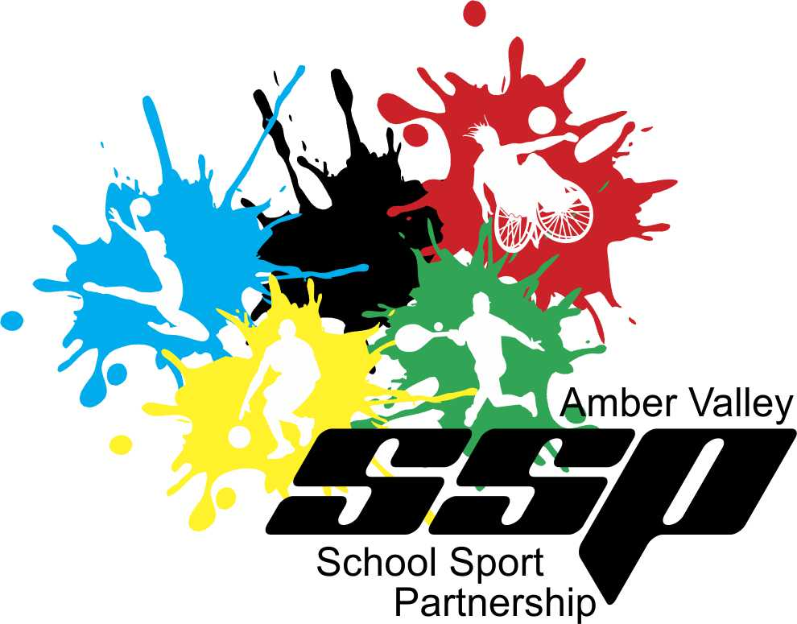

Christ The King School is affiliated to Amber Valley School Sport Partnership who provide a range of services and opportunities to support the school’s delivery of PE, School Sport and Physical Activity.

Through our affiliation we are able to access PE planning resources for each year group themed around 6 different sports. The plans are high quality and easy to follow allowing for staff to plan lessons to suit our school’s facilities and students. Each lesson includes fun, progressive activities from an effective warm-up to a competitive activity with the chance to differentiate learning to support students who are high/low achievers.

Lessons also include technical and tactical teaching points allowing staff to challenge students in a variety of ways. The PE lesson planning we use also includes a PE assessment tracker giving staff the chance to efficiently assess students as Emerging, Expected or Exceeding from a physical, social and emotional standpoint.

Our affiliation package also includes a large number of Inter-school events & competitions in a wide variety of sports. These events are categorised to encourage as many students as possible to represent their school throughout a given year and to help our staff select appropriate students to take part. Our students love taking part in these events and are always really excited to represent their school!

Through our affiliation we are also able to access Bikeability and Learn 2 Ride training which gives many of our students a chance to learn a vital life skill and increase their confidence on their bike as well as work towards earning their certificate!

Christ The King also accesses various activity resources to implement in school, the most useful of which is the Mini Leaders resource. This, along with CPD training and the annual student conference, helps to put in place a culture of junior leadership during lunchtime and throughout the school day. This see’s students leading their peers, providing further opportunities for pupils to be active.

Through our work with Amber Valley School Sport Partnership our staff enjoy regular staff CPD and best practice sharing, support with PE assessment and data collection, assistance with running intra-school competitions and sports days and even guidance when applying for awards and accreditation giving the school chance to help our students become more active and achieve accreditation based on our good work.

Here at Christ The King we try to encourage our pupils to stay active while outside of school hours. We do this by promoting local clubs, activity hubs and leisure providers through various methods including assemblies, fliers, facility usage and extra-curricular links. These external providers include; local Football Teams, Gymnastic clubs and a variety of activities such as swimming at Alfreton Leisure Centre. To encourage pupils to stay active over the

holidays we also actively promote Amber Valley SSP’s Holiday Sports Camps which take place at local leisure centres and offer low cost, high quality sports activities for all pupils. These camps can also be subsidised by the school through Sport Premium or Pupil Premium funding to allow students most in need to attend.

**School Data**

In 2019 our school has attended 7 sporting events and competitions giving our children the opportunity to compete with and against pupils from other schools in Amber Valley in Athletics, Gymnastics, Basketball, Netball and Mini Leaders etc. The children loved taking part and representing their school and even returned with a certificate each for their efforts.

The school even managed finish 2nd in the Gymnastics which was a fantastic achievement among so many other schools! We were incredibly proud of the team!

In total 30% of pupils in the school have represented the school in a competition, something we aim to build on again next year.

Year 5 pupils have completed Bikeability training which helps them learn how to effectively and safely ride a bike and increases pupil confidence in doing so!

Our after-school sports clubs have been really popular this year with full capacity of 15 students taking part in different sports including Circuit Training, Athletics etc and we hope to expand on this next year too!